**Guide to running Amos/T’Pol**



Amos is an Isoprime dual inlet mass spectrometer that measures the stable isotopes of carbon and oxygen in atmospheric CO2. Amos primarily runs flasks but is equipped to run calibration tanks as well. T’Pol primarily runs PFP’s and calibration tanks. Almost all of Amos’s work is connected to the NOAA CMDL Cooperative Air Sampling Network. Air samples are collected in 2.5 liter flasksand are measured for concentrations of CO2, CH4, N2O, H2, and various other trace gases at NOAA. Amos and T’Pol are designed to measure the isotopic ratios (45/44 and 46/44) of CO2 in these samples.

Amos and T’Pol measure three masses:

Mass Species

44 12C16O16O (the most abundant)

45 13C16O16O (carbon 13 isotope)

46 12C18O16O (oxygen 18 isotope)

To measure the stable isotope ratios of CO2, pure CO2 must be extracted from the atmospheric sample. This is accomplished cryogenically: a vacuum pulls the air sample through a mass flow controller set at 40 sccm, through a chilled ethanol bath held at -90°C to freeze out moisture, and into a “triple trap” held at ~–195.5° C with liquid nitrogen to freeze carbon dioxide from the sample (Figure). The other gases-- oxygen, nitrogen, etc. -- are vented away. The triple trap is then heated to –20°C and the sample is released into the sample bellows of the dual inlet. The reference bellows is filled with CO2 from a tank of Niwot Ridge air at the end of every run (therefore, it is isotopically quite similar to our sample gas). Aliquots of sample gas and reference gas are released iteratively into the source, where they are ionized, repelled down the flight tube, and separated by isotopic mass via the electromagnet. They bombard Faraday plates and the current is measured as nanoampere (e-9 amps), which is used to calculate the amount of ions hitting the plate. Then a long sequence of data crunching begins! For more information, visit <https://www.esrl.noaa.gov/gmd/outreach/isotopes/mass_spec.html> to learn about how we measured isotopes of CO2 on Spock.

**The practical stuff: how to run**

1) First things first – check previous nights run, crunch the data

* Look at message log, if run is completed you should see a message ‘*Ending current batch ‘00000.xls’ ‘Kernal stopping inlet script’ ‘…batch report ended’.*
* Open ‘Amos CO2 Crunch’ in C:/ drive. Select *‘Amos CO2 Crunch 1.0.xls’* (say yes to enable macros if asked). Click the crunch button in the upper left corner and choose the run number that you want to crunch (i.e. 000108.xls). This is found in C://->IonVantage Projects ->BatchDB -> current batch file (ex: AmosJuly2020). Say ‘**No’** when asks if want to save changes. Look at crunch and determine if the instrument is good to go for the day!
  + Are the standard deviations of the refs ≤ 0.035/0.045 for δ13C and δ18O?
  + Is the internal precision (columns L and N) less than 0.01?
  + Is the trap on target?
  + Is there a lot of drift in the “virtual ref?”
  + Did the samples run at the target beam (varies by instrument, ~ 4-5 nA)?
* Record all of this information of a run sheet and tape it into the lab book. Copy performance data into the performance file. Save when done.
* Check out longer term monitoring. Watch the trap tank over time, look at drift over time, and watch pair differences to see if they are increasing. There is a lot of useful information in here!

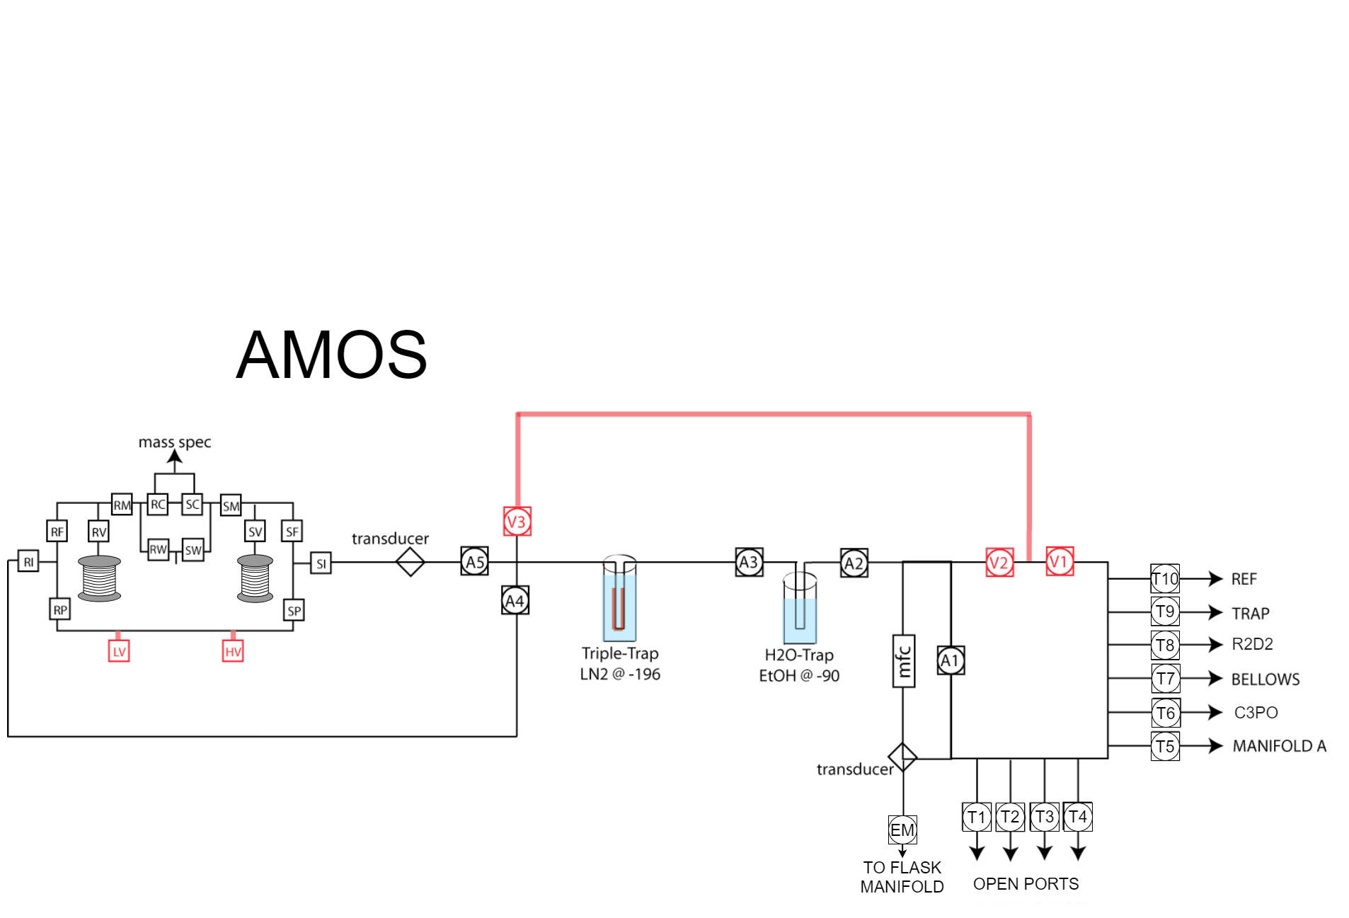

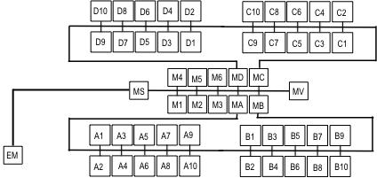

From extraction manifold 🡪

**Figure 1.** A bird’s eye view of Amos’ extraction system and flask manifold.

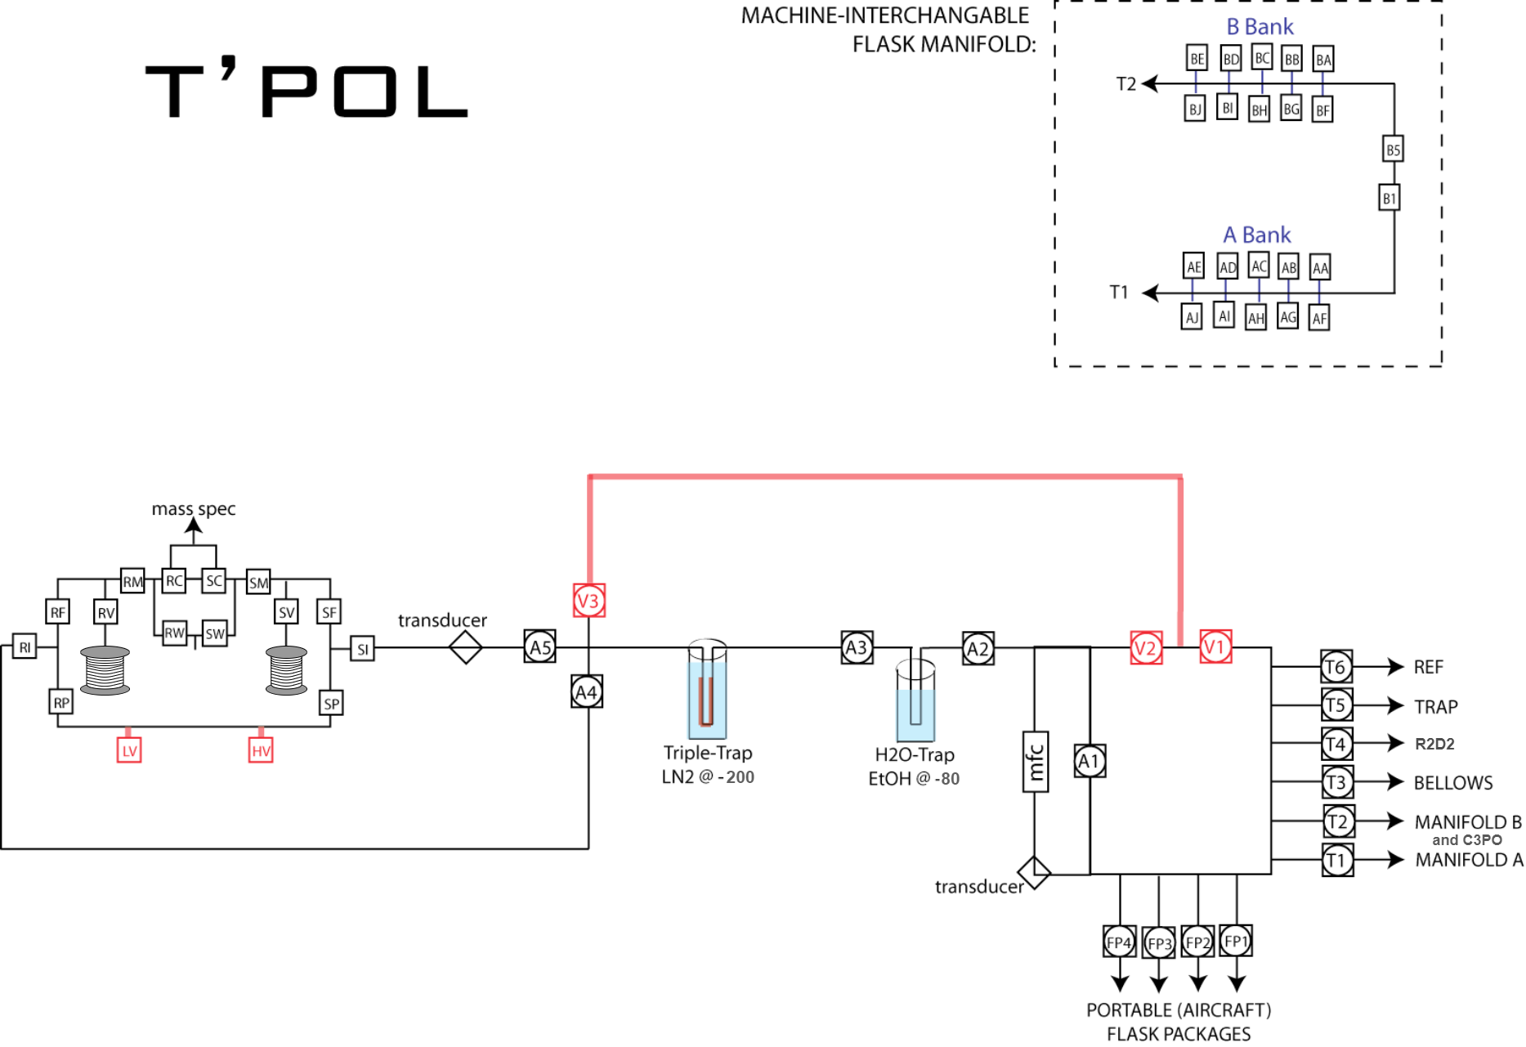

**Figure 2.** A bird’s eye view of T’Pol’s extraction system and manifold.



**Figure 3**. A cross-sectional view of the triple trap. Air is pulled through the tubing, which is within an open-bottomed cylinder and immersed in liquid nitrogen at -200 C. After the extraction, a vent at the top of the cylinder closes, the trap is heated by the wiring wrapped around it, and the vaporized nitrogen displaces the liquid nitrogen. The sample is warmed to -20*C, and is released to the sample bellows.

2) Remove flasks/PFP’s from previous run

* Close all stop-cock valves on the flasks. Remove carefully and determine the next stop on the flasks journey through carbon cycle world. This is designated by the sample pathway on sample sheet. For example, CH4C13, CH3D, CO2C14, VOC. In general, the stable isotopes of CO2 are measured first, then CH413 then VOC then CO2C14.
* Put samples in appropriate sample boxes and transfer to flask storage room where boxes are placed in the correct pile (labeled in flask storage room).
* Finished samples go into boxes on cart with bubble wrap between layers.

3) Prepping instrument

* Switch liquid nitrogen controller to **off** position if there is excess ice buildup on the triple trap. This will allow the excess to melt.
* Close high vacuum (HV) in ‘*Manifold’* tab on inlet page in IonVantage. Open LV, V1, V2 and E1.
* Note the consistency of the EtOH. If slushy, make sure valves around water trap are closed to the vacuum, gently remove the water trap (more instructions on this below), plug the cajons, and pull the container to replace EtOH with bottles from freezer. Do not remove the EtOH unless the water trap is off and plugs are in. Make sure temperature reads at least -85°C on cryocool before starting run. If you want this process to go a little faster, you can fill the EtOH straight from the blue barrels in the walk in freezer.
* Changing water trap:
  + Make sure valves around water trap are closed (E2 and E3).
  + Get new trap from 110°C oven (use glove) and let cool for a minute before you remove old trap. Gently loosen cajon fitting around trap and pull straight down to remove. Carefully set new trap in by pushing directly upward and tightening cajons. If there is going to be an extended time between removal of the old trap and installation of the new trap, fit plugs into the cajons and tighten. This helps prevent EtOH vapor from getting in the system.
  + Evacuate water trap by opening E2 and E3; watch and make sure it pumps down to ~2.3V. Scroll pump will make some noise when pumping down, but it will quiet down after a couple seconds. Close the valves to vacuum and wait a few minutes. If the vacuum reading is stable, the trap held vacuum, and you can pump on it with HV.
  + Amos’ trap can be quite finicky, so make sure it’s secure by *very* gently trying to wiggle it in the cajons. If it doesn’t move, the seal should be good.

4) Loading flasks for new run

* Gather flasks boxes from flask storage room for CO2C13 analysis. Incoming sample boxes are placed on table labeled **‘CO2’.** There are 8 flasks per box (4 pairs). Amos’s manifold can run 40 flasks per run, therefore 5 flask boxes. Glance at sample sheets and make sure you are not getting all of the same site or running a flask that does not belong on the instrument. Try not to run more than 3 pairs of the same site per side in each run.
* Place flasks on the manifold in pairs according to sample sheet. Remove red cap from flask and carefully press glass flask into cajon port. Gently twist until you feel slight resistance to make sure flask is sealed in o-ring.
* Evacuating flasks
  + Close E2 and E3 and open LV. LV, V1, V2 and E1 should all be green.
  + Go to ‘*flask manifold’* tab on inlet and open MV, MA, MB, MC and MD. This evacuates the main tubing leading to manifold.
  + Once pumped down to ~2.8, start opening flask manifold valves, 5 at a time (i.e. A1, A3, A5, A7 and A9).
  + Continue until all valves are open and vacuum is at ~2.8. If not pumping down, check to make sure flask is seated properly in port and that it is closed.
* If running PFP’s on Tpol, hook up both the power supply and the quick connect. Pump the line down by opening the corresponding port (FP 1-5). Close, and wait a few minutes before opening again to make sure the PFP is holding vacuum.

5) Making the session

*This takes the reference tank, flask, and PFP information and neatly puts it into a run sheet for us.*

* On Amos’s computer, go to <http://om.cmdl.noaa.gov/sb/> (should be pinned or start typing in search bar). Username is sil and password is “20020118”. Choose VG Isoprime (“Amos” SIL double trap).
* The center scroll bar allows you to choose which type of sample you would like to enter. The options for that type appear on the left, and based on your choice, can be appended onto the window on the right. This will become your sample list for that run. To begin choose the reference tank and click “**ok**”. For Amos, the current reference is CHIC. Its information, not including sample port (10), will appear in the center. If you change your choice in the left window, click “ok” for it to update in the center panel. Once you are satisfied with your choice of working reference, click “**append**” four times so that the first four samples of the run are of that working reference.
* To enter flasks, scroll down to CCGG flask in the middle bar. Enter the flask ID in the left window to find the flask in question. Press ok and it will automatically update the center panel. Append that information into your sample list and check that everything is correct. The ports will automatically begin with 11 (A1) and update sequentially. You will need to change flask port after TRAP is entered. See port-valve identifications on side of Amos computer.
* Enter PFP’s by selecting CCGG PFP in the center panel. Type the PFP in question into the left panel, and select (using the control key) all of the samples in the PFP that are being run for CO2C13 (beware, not all samples will be on the CO2C13 list). Press okay and append to the run.
* Hit save. A new tab will open with your freshly made run, but it’s not quite formatted for IonVantage yet. Copy the run and paste into an excel file.
* Highlight the list and click Data -> ‘Text to Columns’ -> delimited -> next -> comma -> next.
* Copy and paste this text into IonVantage, make sure there is the proper amount of cells to fit all of the rows for the session.
* On IonVantage session builder, make sure the ‘bottle’ column represents the correct ports for each sample, reference and trap tank.
* Save the run in IonVantage as the new run number with three 0’s before the run number.

6) Tuning

*We tune the machine daily to get the best possible beam –we see this on the screen as a peak. This requires letting reference gas into the mass spec and watching the peak as we make adjustments. (Note we want the three beams to be coincident at the top of peak. Magnet position and tuning values can affect peak shape)*

* While evacuating flasks, the instrument can be tuned. See manual for specifics on each parameter.
* Open RV and RM. Toggle c/o so that RC and SW are green and SC and RW are red. This allows reference gas that is in reference bellows to enter the source. Allow couple minutes to stabilize. Beam should be between 1.5 nA to 2.5 nA without the bellows squished at all. This is enough gas to get us through a run. Too much gas may make it difficult to balance the bellows with lower pressure samples.
* In tune window, click on three shortcut buttons for the tune page, scan, and center scan (buttons look like line graph and list). Click on ‘*Run Center Scan’.*
* You are looking for a nice flat, square peak.
* Fine-tune the peak by adjusting the following parameters: HP, Z, IR, EX, and EV. Go to *“***Acquire***”* in tuning window and run each of these scans. This should not change too much from day to day.
  + HP. *Half plates. These are the first plates that the ions go through as they leave the source.* Zoom into the peaks of the major and minor beam scans and enter their maxima into the source parameter (or drag the red line there). If the peaks are not coincident, find a compromise between them. If you change the peak center, click save/accept peak center.
  + Z plate. *The z plates narrow the beam in the y plane, whereas the half plates narrow the beam in the x plane.* Zoom into the peaks of the major and minor beams, and find the spot that maximizes both of them the best.
  + IR. *This is the voltage of the ion repeller, which repels the ions out of the source and down the flight tube.* Find the peak of the major and minor beams in this scan, then go between 1.4 to 1.75 V to the left of it. Currently the IR is approximately -6 V. Do not venture beyond the range of -5 to -9. Change with caution.
  + EX.Find the peak of major and minor beams in the Extraction Voltage scan and go approximately 0.2 V to the left of it. Usually around 70 V.
  + EV. The Electron Voltage scan does not always have a clear peak. Make sure that you are not set in a strange slope or dip, and select the largest peak, or the peak closer to ~90V. Usually around 90 V.
* Once you have a nice center scan, close RV.
* Note tuning parameters down in notebook if anything major changes.
* To find a peak you can go back in the notes and view a previous AV, and adjust to those numbers. If you still can find the peak, just ask for help. ☺

7) Almost there…

* Check to make sure you have enough liquid nitrogen and that control is **on** automatic.
* Make sure EtOH is cold (At *least* -75°C when you start the run).
* Did you check that all flasks, PFPs, and tank lines (only if the tank is closed, also not necessary for the instruments resident tanks) are holding vacuum?
* Start the run. When you see that the first couple samples are good, open flasks/samples. PFP’s will open on their own and do not need to be manually opened.